General formula of alkane is
A. $C_{n}H_{2n}$
B. $C_{n}H_{2n+2}$
C. $C_{n}H_{2n-2}$
D. None of the above
ANSWER: B

$-X$ indicates which of the following functional group?
A. Alcohol
B. Alkyl
C. Alkane
D. Halide
ANSWER: D

Which of the following have $-OH$?
A. Alkyl halides
B. Alcohols
C. Phenols
D. Both alcohols and phenols
ANSWER: D

Olefinic double bond is the functional group of _____.
A. Alkanes
B. Alkenes
C. Alkynes
D. None the above
ANSWER: B
$C_{6}H_{14}$ is the formula of
A. Hexene
B. Hexane
C. Hexyne
D. None of the above
ANSWER: B
Which of the following is a Ketone
A. CH₃-O-CH₃
B. CH₃-CHO
C. C₂H₅-CO-C₂H₅
D. CH₃-COOH
ANSWER: C
A homologue differs from the proceeding member of
A. $CH$
B. $CH_{2}$
C. $CH_{3}$
D. None of the above
ANSWER: B

Which of the following indicates $-C≡C-$?
A. Alkanes
B. Alkenes
C. Alkynes
D. None of the above
ANSWER: C
Which one of the following compound belongs to the homologous series of aldehydes?
A. 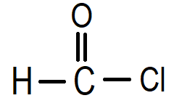
B. 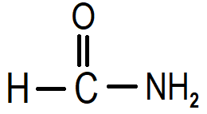
C. 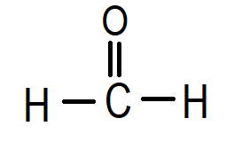
D. 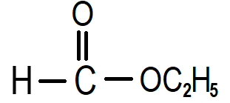
ANSWER: C
Which of the following is the simplest alkane?
A. Ethane
B. Methane
C. Propane
D. Ethene
ANSWER: B

Which of the following is a Ketone?
A. $CH_{3}-O-CH_{3}$
B. $CH_{3}-CHO$
C. $C_{2}H_{5}-CO-C_{2}H_{5}$
D. $CH_{3}-COOH$
ANSWER: C
$C_{6}H_{14}$ is the formula of
A. Hexene
B. Hexane
C. Hexyne
D. None of the above
ANSWER: B

Alkynes have the general formula
A. $C_{n}H_{2n+2}$
B. $C_{n}H_{2n}$
C. $C_{n}H_{2n-2}$
D. $C_{n}H_{2n-6}$
ANSWER: C
An atom or group of atoms which confers characteristic properties to and organic molecule is called
A. Radical
B. Functional group
C. Polymers
D. None of these
ANSWER: B
Which of the following statement is correct about homologue?
A. The molecular mass of each homologue differs by 14
B. Homologues differs in their physical properties
C. Homologues have the same functional group in them
D. All of the above
ANSWER: D

